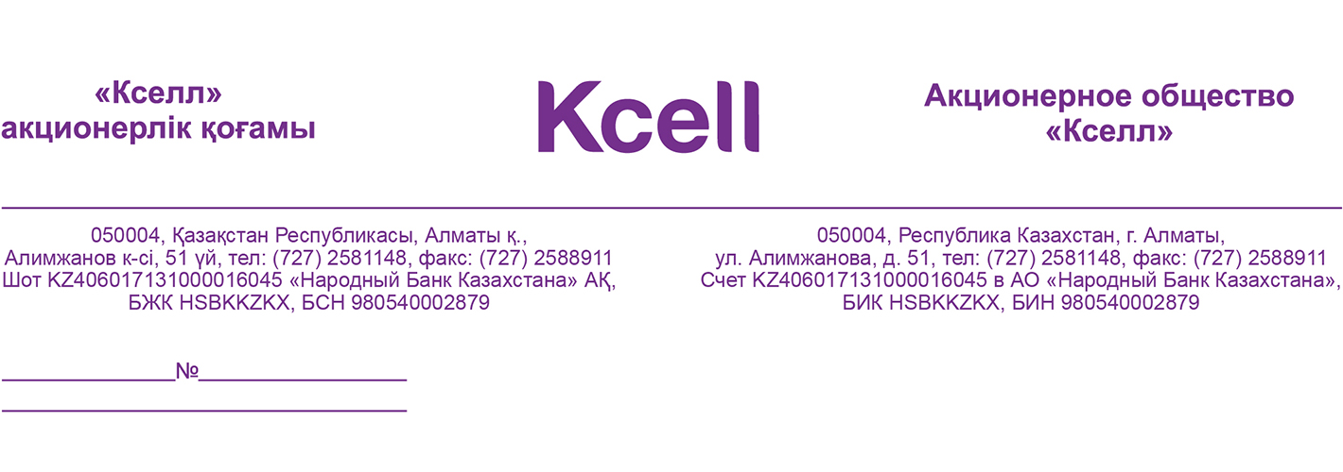

Title
Organization
Attn. of Mr./Ms. (Name)

Dear ____________________________,
Thank you for taking your time to meet with us and the opportunity to inform you in more detail about the services and products of Kcell JSC.

By this commercial offer we confirm our preliminary verbal agreements:
(перечислить по пунктам все вопросы, обсужденные на встрече)

Based on the mentioned above, we are happy to offer you our Revolving Package service that automatically changes your outgoing number to any other number from a set of numbers allocated to your company as part of the service.

The service helps businesses like banks and collection agencies increase the call success rate as they track down their debtors due to constantly changing outgoing numbers.

We also have other add-on services available for our corporate customers. Please, see the list of services and their brief descriptions in Appendix 1 to this letter.

Advantages:
- Call Success Rate increases by up to 15%;
- Phone numbers allocated based on your preferences
- Call back

Revolving Package – service charge
Table 1 – Monthly fee for a package of numbers *
Package | Numbers in a package | Monthly fee, tenge, incl. VAT
Package 1 | 1-60 | 36 000
Package 2 | 61-100 | 50 000
Package 3 | 101-250 | 100 000
Package 4 | 251-500 | 150 000
Monthly fee is due on the 1st of month following the accounting month, irrespective of the service activation or deactivation date. Where service is activated any time after the 1st of month, the full amount of fee will be collected upon activation and then on the 1st of each month. Outgoing calls are billed based on the rate provided in Table 2.

Table 2 – Outgoing call rates
Call direction | Per minute rate, tenge, incl. VAT | Billing increment
Onnet (Kcell, activ) | 11 | 1 sec
Within corporate group | 11 | 1 sec
To other KZ mobiles | 11 | 1 sec
To KZ landlines | 17 | 1 sec

Table 3 – Change of package of numbers
Package | Numbers in a package | Number change one-time fee*, tenge, incl. VAT
Package 1 | 1-60 | 36 000
Package 2 | 61-100 | 50 000
Package 3 | 101-250 | 100 000
Package 4 | 251-500 | 150 000
*One-time fee is charged to the client’s account on the 1st of month following the month in which the number change occurred, irrespective of the date of such change.

PBX scheme
- Direct connection is established over SIP signal system or PRI protocol;
- Number format on Kcell network: XXXXXXXXXXXXXXXX (16 digits), where the first 5 digits is prefix (+99998) and 11 digits are the called phone number (e.g. +99998 77011234567);
- This scheme may be adjusted to your technical conditions:

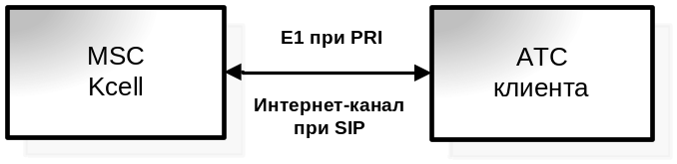

Should you have questions or wish to find out more about our services, products and tariffs, our consultants and your personal manager will be there for you provide to provide you with more information or assistance. You can also contact us on 9090 from mobile (24/7), +7 (727) 2588 300 from 8:00 to 22:00 on weekdays, +7 (727) 2587 021 from 10:00 to 18:00 on weekends.

Please, be advised that this offer is valid for 30 days and we would appreciate if you could reply by the end of this term.

Sincerely yours,
Dmitriy Agaltsov
Director
Enterprise Department
Appendix 1
Add-on services
Business Telephony allows clients to set up their private PBX and thus reduce their fixed-to-mobile and mobile-to-fixed costs.

Revolving Package – a service that automatically changes your Caller ID to any other number from a set of numbers allocated to your company. It helps businesses like banks and collection agencies increase the call success rate as they track down their debtors thanks to alternating caller IDs.

Mobile office – with this service you can set up your own mini Call Center to accept calls coming to your PBX and transfer them to appropriate employees.
Club 7.0.1 is the advertising space that businesses can use to advertise their products and services by means of SMS, audio ads or direct calls to the Club members based on pre-defined targeting criteria.

Business Pulse – is a mobile version of Complaints & Suggestions Book. It allows businesses to get SMS-based feedback on their products or services from customers across Kazakhstan.

Telesurvey – telephone surveys conducted by Kcell Call Center.

Commercial report – a service that allows clients to receive location-based analytical data, such as number of customers in a certain location, average mobile bill, registration data, mobile device, activated services, etc.

Bulk SMS service allows users to send a single text message to multiple numbers simultaneously

DATA/FAX – a service that allows client terminals to exchange messages, files or other data by means of CSD Circuit Switched Data technology. Mobile phones with GSM-modem feature and other devices that support CSD can be used as client terminals.

Fixed Internet – service that provides users a broadband Internet access through radio relay or optic links.

Enterpriser network (corporate network) – services that allows clients to integrate and connect their offices and facilities into a single network and provide users secure access to their corporate information resources from any location.

Kcell Cloud – services used to store and manage client data based on Kcell’s infrastructure.

DDoS attack protection – service useв to analyze client’s Internet traffic for mass cyber-attacks in order to ensure stable and uninterrupted performance за client’s information resources through HTTP or HTTPS protocols.

Enterprise software from leading providers like ABBYY, ADOBE, Autodesk, Avira, Corel, DrWeb, ESET, CommVault, Kerio, McAfee, Microsoft, PROMT, Symantec, Veritas, Veeam, Kaspersky, UserGate, Avast, WinRAR, Famatech_(Radmin), TeamViewer, Fast Reports, TrendMicro.

Corporate RBT service allows users to replace standard ringing tones with their corporate anthems or special greeting messages.

Info Center is a system that allows making automatic calls and interactive voice communication with customers.

Limit control service allows users to break an account into several virtual subaccounts and set each a credit (usage) limit.

My New Number allows you to notify all your contacts that your mobile number has changed.

Free Phone is a service where calls to short numbers are paid by the called party, not by caller.

Telemetry service allows connecting remote terminals via GPRS to form a single virtual network.

Static IP – service used to assign your equipment, such as POS-terminals, PC and other terminal equipment an unchanged Static IP.

Limit control service allows users to break an account into several virtual subaccounts and set each a credit (usage) limit.

3G USB Modem provides remote access to the Internet.

Wi-Fi Router is a small portable device. It is mobile access point (Wi Fi router) that requires a SIM-card and distributes a wireless signal to all of your devices that support Wi Fi: laptop, iphone, ipad, Wi-Fi printer, etc.

Data/Fax transfer allows users to send/receive fax and data over a voice channel.

Vehicle Tracking allows users to track their fleet of vehicles and any other objects in real-time.

Simplified Document Flow service will help reduce (get rid of) paper-based document flow; save time and resources; have your request dealt with by a dedicated account manager; submit letters/requests via e-mail or fax (no original hardcopy required).

М2М Thermo SIM Card is specifically designed for usage in data transfer devices in the complicated environment. Unlike conventional ones, the M2M thermo SIM-card:
- disabled no authentication counter;
- is made of highly durable heat-resistant plastic;
- is resistant to corrosion of the contact group;
- has a longer lifespan;
- is able to smoothly operate in the temperature range between -40 °C to +105 °C.

CICS (Corporate Internet-based Customer Service) is a handy tool to get information about the status of a corporate group, it provides access to up-to-date information about personal accounts through the Internet independently without the help of Kcell operator. With CICS you can:
- Check your account balance;
- Get information on services that are active on your account and prices;
- View credited payments;
- Activate / deactivate services, for a particular account or entire corporate group;
- Get a copy of your invoice;
- Get Call Detail Report (CDR) for previous periods;
- Block/unblock accounts;
- Change your invoice delivery address:
- Check what tariff plans are used by your corporate group accounts;
- Get information on ordered bills and CDR and order status;
- Pay with a top up card;
- Change password;
- Get detailed information you want to know from your dedicated account manager.

